1.Git Setup<https://confluence.atlassian.com/bitbucket/set-up-git-744723531.html>

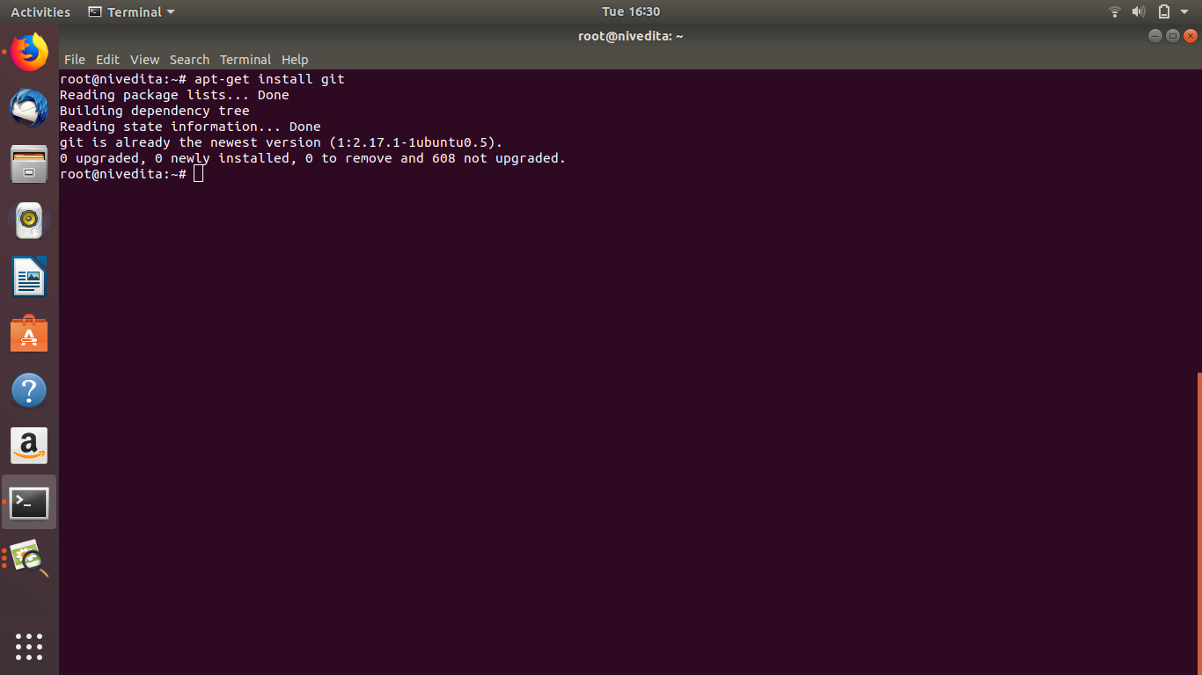

2.Initialize a Git Repository

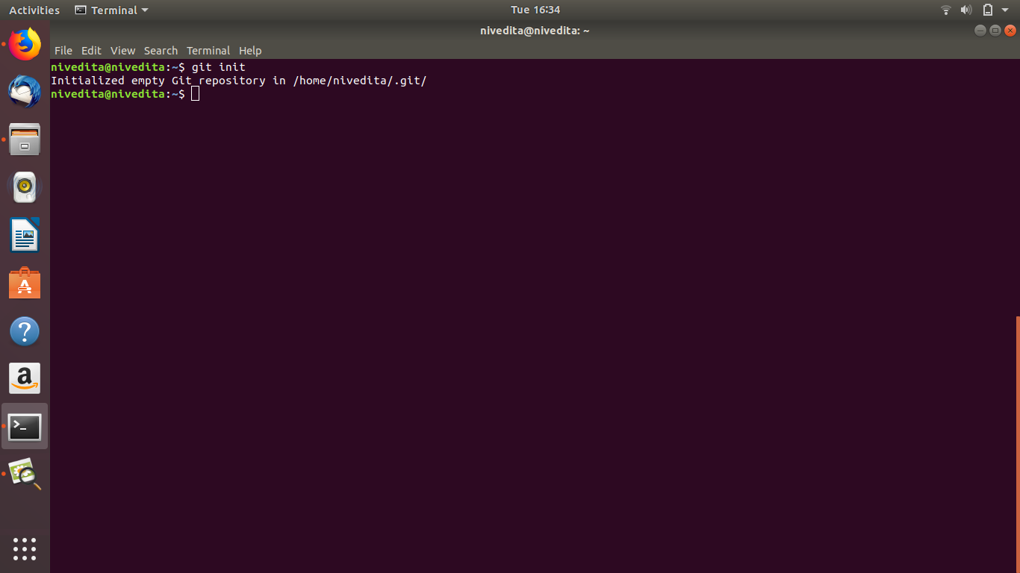

3.Add files to the repository